|  |  |  |  |  |  |  |
| --- | --- | --- | --- | --- | --- | --- |
| Description: Vertical full colour positive | Safety Bay Senior High School | | | | | |
| **CHEMISTRY UNIT 3 & 4** | | | | | | |
| **Test #3:** | | | | | | |
| **Oxidation and Reduction** | | | | | | |
|  | | | | | | |
| **NAME:** | | |  | | | |
|  | | |  | | | |
| **Time allowed for this paper** | | | | | | |
| Reading time: | | 5 minutes | | | | |
| Working time: | | 50 minutes | | | | |
|  | | | | | | |
| **Structure of this paper:** | | | | | | |
| Section | | | Number of questions | Marks available | | Marks achieved |
| Section One: Multiple Choice | | | 8 | 8 | |  |
| Section Two: Short Answer | | | 7 | 42 | |  |
|  | | |  | | **Total** | ______ / 50 |

**Section One: Multiple Choice**

Answer all questions by circling the correct option. Only circle one option for each question.

1. The oxidation number for chromium in the dichromate ion (Cr2O72–) is:
   1. +3
   2. +4
   3. +5
   4. **+6**
2. The oxidation number for sodium in sodium peroxide (Na­2O2) is:
   1. **+1**
   2. +2
   3. +3
   4. +4

**Questions 3-4 refer to the following reaction:**

2 NaOH + Cℓ2 → NaCℓ + NaCℓO + H2O

1. Which option on the table below correctly identifies the oxidant and reductant in the above reaction?

**Oxidant Reductant**

* 1. NaOH Cℓ2
  2. Cℓ2 NaOH
  3. NaOH NaOH
  4. **Cℓ2 Cℓ2**

1. What term is used to describe this reaction?
   1. Displacement reaction
   2. Acid-base reaction
   3. **Disproportionation reaction**
   4. Electrolytic reaction
2. Which of the following chemical species is capable of converting Cu2+ into Cu(s)?
   1. Pt
   2. **Fe**
   3. Au
   4. HCℓ
3. Which of the following describes the halogens as you go down Group 17?
   1. They become stronger reductants
   2. They become weaker reductants
   3. They become stronger oxidants
   4. **They become weaker oxidants**

**Question 7 refers to the following electrochemical cell:**

KNO3 salt bridge

platinum electrode

copper electrode

Fe3+

V

Fe2+

SO42-

Cu2+

SO42-

Reduction half-equations:

Fe3+ + e⁻ → Fe2+ E° = 0.77 V

Cu2+ + 2 e⁻ → Cu E° = 0.34 V

1. Which of the following equations would be used to calculate the voltage of the cell under standard conditions?

|  |  |
| --- | --- |
| **(a)** |  |
| (b) |  |
| (c) |  |
| (d) |  |

1. Why does the hydrogen half-equation (2 H+ + 2 e⁻ → H2) have a standard reduction potential of 0.000 V?
   1. The value has been measured very precisely
   2. **It is an arbitrary set reference**
   3. Hydrogen ions have no ability to attract electrons
   4. The half-cell cannot produce current

**Section Two: Short Answer**

Write your answers in the spaces provided.

1. **(7 marks)**
   1. Write balanced ionic equations, including state symbols, for the following reactions: (3 marks)

|  |  |
| --- | --- |
| **Answer** | **Cumulative Marks** |
| Zn(s) + Ni2+(aq) → Zn2+(aq) + Ni(s) | 1 mark |
| F2(g) + 2 I⁻(aq) → 2 F⁻(aq) + I2(aq) | 1 mark |
| Correct use of state symbols, ionic equations | 1 mark |
| TOTAL: | 3 marks |

* 1. Explain why the reaction in Q9(a) is considered a ‘redox’ reaction. (2 marks)

|  |  |
| --- | --- |
| **Answer** | **Cumulative Marks** |
| Zn loses two electrons and is oxidised | 1 mark |
| Ni2+ gains two electrons and is reduced | 1 mark |
| TOTAL: | 2 marks |

* 1. Describe what would be observed in the beaker as the reaction in Q9(a) occurs. (2 marks)

|  |  |
| --- | --- |
| **Answer** | **Cumulative Marks** |
| Green colour of solution fades | 1 mark |
| Grey/silver/black solid forms on outside of zinc | 1 mark |
| TOTAL: | 2 marks |

1. **(4 marks)**

The following reaction shows a process used in the extraction and purification of gold:

Au(s) + 3 HNO3(aq) + 4 HCℓ(aq) → HAuCℓ4(aq) + 3 NO2(g) + 3 H2O(ℓ)

Identify the oxidising agent and reducing agent in this reaction. Give evidence to support your answer.

|  |  |
| --- | --- |
| **Answer** | **Cumulative Marks** |
| Au(s) is reducing agent.  It causes the N in HNO3 to be reduced from +5 to +4 | 1 mark  1 mark |
| HNO3(aq) is the oxidising agent  It causes the Au in Au(s) to be oxidised from +0 to +3 | 1 mark  1 mark |
| TOTAL: | 4 marks |

*Award 3/4 if students misread question and instead correctly identify and explain what is oxidised and what is reduced (rather than identify the oxidising agent and reducing agent).*

1. **(7 marks)**

A galvanic cell was constructed as shown in the diagram below:

KCℓ(aq)

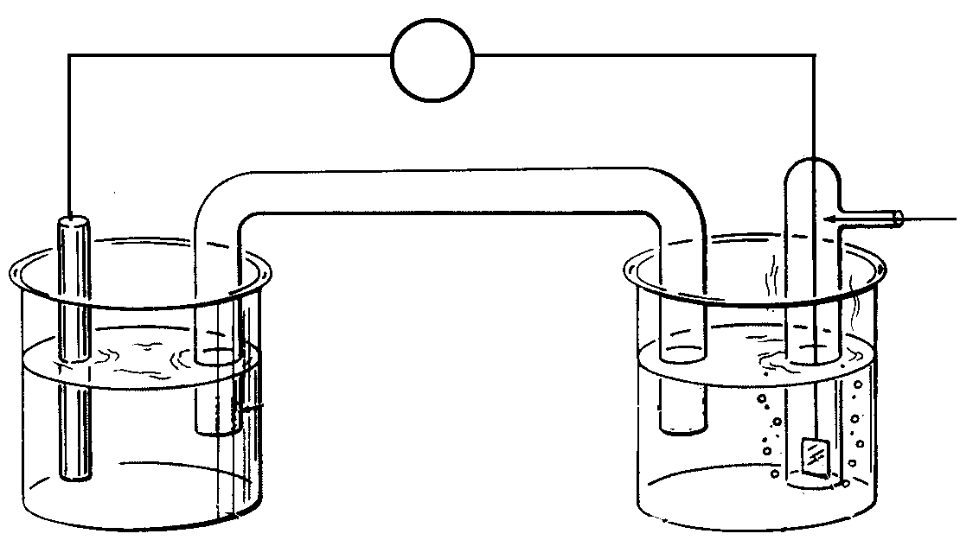

Cℓ2(g)

Pt(s)

Cr(s)

V

Salt bridge (NH4Cℓ)

CrCℓ3(aq)

A

B

* 1. Write the oxidation and reduction half-equations, and a balanced overall redox equation for this reaction. (3 marks)

|  |  |
| --- | --- |
| **Answer** | **Cumulative Marks** |
| Oxidation: Cr(s) → Cr3+(aq) + 3 e⁻ | 1 mark |
| Reduction: Cℓ2(g) + 2 e⁻ → 2 Cℓ⁻(aq) | 1 mark |
| Overall: 2 Cr(s) + 3 Cℓ2(g) → 2 Cr3+(aq) + 6 Cℓ⁻(aq) | 1 mark |
| TOTAL: | 3 marks |

*Award 2/3 if half-equations are correct but are placed in the wrong boxes.*

* 1. Name the anode and cathode in the above cell: (2 marks)

|  |  |
| --- | --- |
| **Answer** | **Cumulative Marks** |
| Anode: Chromium | 1 mark |
| Cathode: Platinum | 1 mark |
| TOTAL: | 2 marks |

* 1. Between the points labelled A and B, show the direction of electron flow. (1 mark)

|  |  |
| --- | --- |
| **Answer** | **Cumulative Marks** |
| A 🡪 B | 1 mark |
| TOTAL: | 1 mark |

* 1. Show on the diagram the direction of ion flow in the salt bridge. (1 mark)

|  |  |
| --- | --- |
| **Answer** | **Cumulative Marks** |
| 🡨 Cℓ⁻ NH4+ 🡪 | 1 mark |
| TOTAL: | 1 mark |

1. **(6 marks)**

The following diagram shows a form of electrolysis:

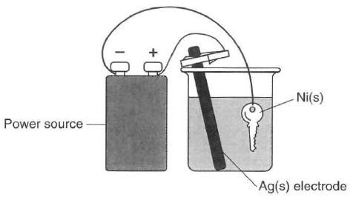

* 1. Give the name of this application of electrolysis, and describe its purpose in this particular scenario. (2 marks)

|  |  |
| --- | --- |
| **Answer** | **Cumulative Marks** |
| Electroplating OR metal plating | 1 mark |
| To coat the key with a layer of silver | 1 mark |
| TOTAL: | 2 marks |

* 1. Write half-equations showing the process occurring at the: (2 marks)

|  |  |
| --- | --- |
| **Answer** | **Cumulative Marks** |
| Anode: Ag(s) → Ag+(aq) + e⁻ | 1 mark |
| Cathode: Ag+(aq) + e⁻ → Ag(s) | 1 mark |
| TOTAL: | 2 marks |

*Award 1/2 if equations correct but in wrong boxes.*

* 1. Give the name or formula of a suitable electrolyte for this cell. (1 mark)

|  |  |
| --- | --- |
| **Answer** | **Cumulative Marks** |
| Silver nitrate (AgNO3) OR silver ethanoate (AgCH3COO) | 1 mark |
| TOTAL: | 1 mark |

* 1. What is the purpose of the power source in this cell? (1 mark)

|  |  |
| --- | --- |
| **Answer** | **Cumulative Marks** |
| (Provide a potential difference to) force a non-spontaneous redox reaction to occur | 1 mark |
| TOTAL: | 1 mark |

1. **(4 marks)**

‘Breathalysers’ are instruments used by police to measure the concentration of ethanol (C2H5OH) in a driver’s breath. One type of breathalyser used is a fuel cell. If the driver’s breath contains ethanol then a redox reaction will occur. The ethanol reacts to form ethanoic acid (CH3COOH) and oxygen from the air reacts to form water vapour. Both reactions occur in acidic conditions.

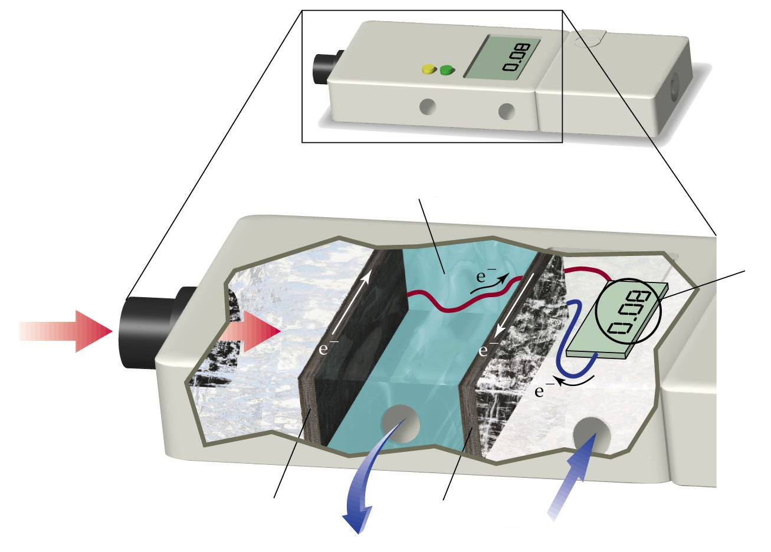

C2H5OH

acidic electrolyte

air   
intake

O2

waste   
products

Driver’s  
breath

Blood alcohol level

Electrode

**(positive)**

Electrode

**(negative)**

* 1. Complete the half-equations below to show the reactions occurring in each section of the breathalyser. Both reactions occur in acidic conditions. (4 marks)

|  |  |
| --- | --- |
| **Answer** | **Cumulative Marks** |
| **H2O +** C2H5OH → CH3COOH **+ 4 H+ + 4 e⁻** | 2 marks |
| **4 e⁻ + 4 H+ +** O2 → **2** H2O | 2 marks |
| TOTAL: | 4 marks |

*Deduct 1 mark per mistake. Follow through balancing H2O, H+, e⁻.*

* 1. Label the diagram to show the charges of the two electrodes. (1 mark)

|  |  |
| --- | --- |
| **Answer** | **Cumulative Marks** |
| Left-hand electrode (anode) is negative  Right-hand electrode (cathode) is positive | 1 mark |
| TOTAL: | 1 mark |

* 1. What characteristic of this breathalyser allows it to be classified as a “fuel cell”? (1 mark)

|  |  |
| --- | --- |
| **Answer** | **Cumulative Marks** |
| There is a continuous supply of reactants | 1 mark |
| TOTAL: | 1 mark |

1. **(4 marks)**

The lithium button cell, used to power watches and calculators, is a primary cell containing lithium metal. The lithium ion cell is a secondary cell that is used to power laptops.

|  |  |
| --- | --- |
| http://img.dxcdn.com/productimages/sku_34712_4.jpg | https://upload.wikimedia.org/wikipedia/commons/1/1a/Li_ion_laptop_battery.jpg |
| Lithium button cell | Lithium ion cell |

The half-equation for the reduction of lithium is:

Li+(aq) + e⁻ → Li(s) E° = -3.04 V

* 1. What is the difference between a primary and secondary cell? (1 mark)

|  |  |
| --- | --- |
| **Answer** | **Cumulative Marks** |
| Seconds cells can be recharged. Primary cells cannot. | 1 mark |
| TOTAL: | 1 mark |

* 1. Give one reason why lithium is used as a reactant in these galvanic cells. (1 mark)

|  |  |
| --- | --- |
| **Answer** | **Cumulative Marks** |
| Any one of following:   * Lithium is a strong reductant * Li+(aq)/Li(s) has a (very) low E° value * Lithium is more readily oxidised than other substances * Lithium cells produce high voltages | 1 mark |
| TOTAL: | 1 mark |

Some early lithium metal batteries exploded when exposed to water.

* 1. Write a balanced equation for the reaction between lithium metal and water and explain why an explosion may occur. (2 marks)

|  |  |
| --- | --- |
| **Answer** | **Cumulative Marks** |
| 2 H2O(ℓ) + 2 Li(s) → H2(g) + 2 OH⁻(aq) + 2 Li+(aq) | 1 mark |
| Can cause an explosion due to build-up of pressure from gas  and/or  Can cause an explosion because the hydrogen gas produced is flammable | 1 mark |
| TOTAL: | 1 mark |

1. **(8 marks)**

The bromate ion (BrO3⁻) is an ion formed by the ozonation of drinking water. Bromate ion is a powerful oxidising agent and can react in the presence of an acid to form bromine (Br2).

* 1. Write a half-equation showing the reduction of the bromate ion to form bromine. (2 marks)

|  |  |
| --- | --- |
| **Answer** | **Cumulative Marks** |
| 2 BrO3⁻(aq) + 12 H+(aq) + 10 e⁻ → Br2(aq) + 6 H2O(ℓ) | 2 marks |
| TOTAL: | 2 marks |

*Deduct 1 mark per mistake. Follow through balancing H2O, H+, e⁻.*

* 1. Information about the oxidising power of the bromate ion can be gathered by observing what other species it is able to react with.

A student constructed the following two electrochemical cells and allowed each cell to operate for five minutes. In their notes they recorded the initial and final appearance of each half-cell. All cells were constructed under standard conditions.

**Electrochemical Cell #1 (EC1): Electrochemical Cell #2 (EC2):**

salt bridge

C(s)

BrO3⁻(aq)

Cr3+(aq)

C(s)

salt bridge

C(s)

BrO3⁻(aq)

Mn2+(aq)

C(s)

*Initial appearance:*

Pale pink solution

*Final appearance:*

Pale pink solution

*Initial appearance:*

Colourless solution

*Final appearance:*

Colourless solution

*Initial appearance:*

Green solution

*Final appearance:*

Orange solution

*Initial appearance:*

Colourless solution

*Final appearance:*

Brown solution

* + 1. Account for the colour changes in EC1 (Electrochemical Cell #1). (3 marks)

|  |  |
| --- | --- |
| **Answer** | **Cumulative Marks** |
| Brown colour is due to the production of Br2(aq) | 1 mark |
| Colour change from green to orange shows Cr3+ is reacting to make Cr2O72- | 1 mark |
| *(Supports answer with relevant half-equation)*  2 Cr3+(aq) + 7 H2O(ℓ) → Cr2O72-(aq) + 14 H+(aq) + 6e⁻ | 1 mark |
| TOTAL: | 3 marks |

* + 1. Explain how the observations in EC1 and EC2 can be used to gain information about the standard reduction potential (E°) of bromate ions. (3 marks)

*In EC1, BrO3⁻ was able to oxidise Cr3+ to Cr2O72-. This means that BrO3⁻ is a more powerful oxidant than Cr2O72-, and has a standard reduction potential (E°) > +1.36 V.*

*In EC2, there was no reaction. This indicates that BrO3⁻ was not able to oxidise Mn2+ to MnO4⁻. BrO3⁻ is a weaker oxidant than MnO4⁻, and therefore has a standard reduction potential (E°) < +1.51 V.*

*Combining this information tells us that the reduction potential of BrO3⁻ is somewhere between +1.36 V and +1.51 V.*

|  |  |
| --- | --- |
| **Answer** | **Cumulative Marks** |
| Uses EC1 to determine E°(BrO3⁻) > +1.36 V | 1 mark |
| Uses observations from EC2 to determine that Mn2+ was not reduced to MnO4⁻ | 1 mark |
| Uses EC2 to determine E°(BrO3⁻) < +1.51 V | 1 mark |
| TOTAL: | 3 marks |